**Gains during Coding**

* Reminder: when adjusting the size of the ***icon from FontAwesome, we can either include the class “fa-2x, fa-3x & etc” or manipulate the CSS font-size attribute***
  + ***We are not adjusting the CSS width attribute***
* When clicking the button *(despite the background and border are set to “none” ), there* ***are still some outlines exist upon clicking***

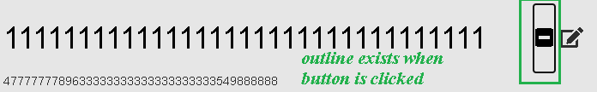

* + Solution: ***manipulate the CSS outline attribute***
  + ***CSS “outline” attribute***

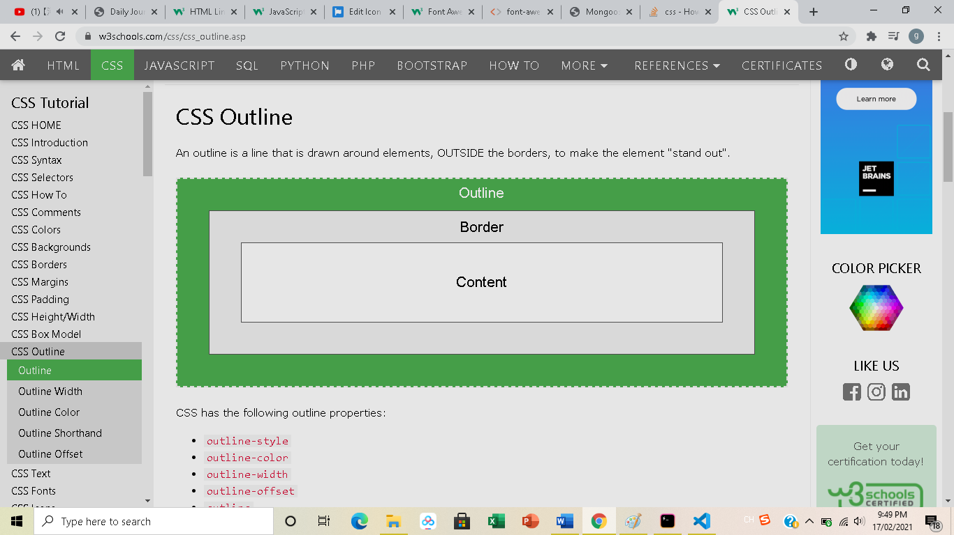

* + Set the outline attribute to ***none***